Darnell Chen  
Lab Report  
ECE 2031 L02  
18 January 2025

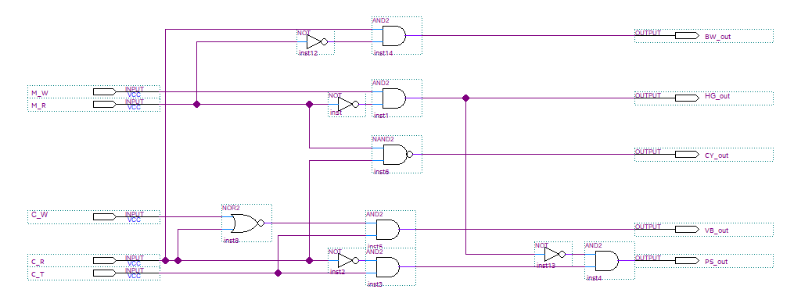

**Figure 1.** Combinational Logic Circuit where LEDs light up for certain switch inputs. The switches represent weather sensors, and the LEDs represent suitable activities for the given weather.

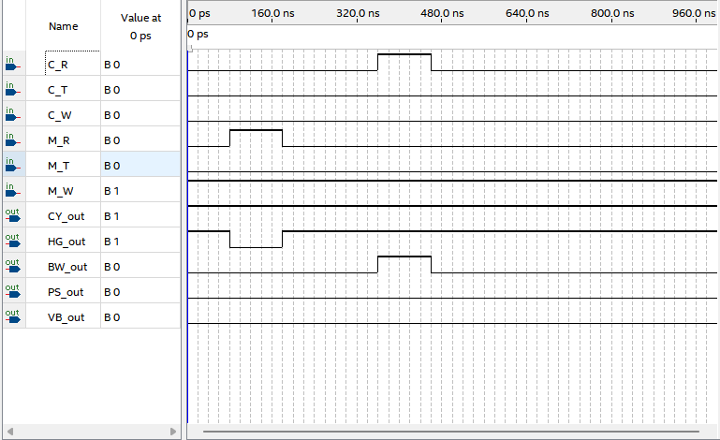

**Figure 2.** Wave form for our suitable activities device. High assertion for windy mountains (M_W) and rainy mountains (M_R) results in a low-assertion for Hang Gliding. On the other hand, high assertion for coastal rain and low assertion for rainy mountains produces a high assertion for birdwatching.

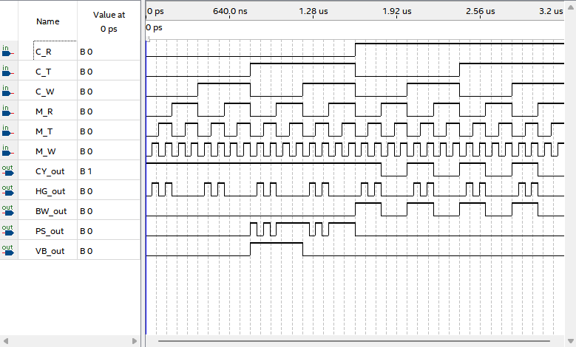

**Figure 3.** Waveform which produces every combination of input and output possible. Each sequential input from top to bottom has half the periodic interval compared to the input above it.

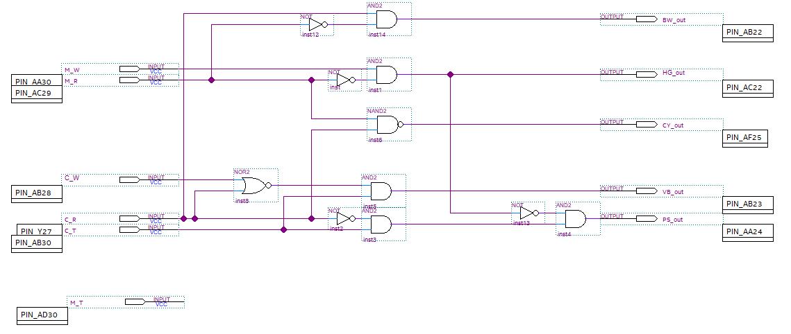

**Figure 4.** Pin assignments for our LED and Switches as per our DE10-Standard user manual.